**Micro-Project (Part-2)**

*For partial fulfillment of Activity Based Learning*

*for Course*

**Data Communication & Networking (3028)**

**Network Design Task-02**



**Submitted By:**

**Arpita Srivastava (2104069)**

**Navanita Das (2104111)**

**Saurav Kr. Yadav (2104117)**

**Rashmita Biswal (2104118)**

**School of Electronics Engineering**

**Kalinga Institute of Industrial Technology (KIIT)**

**Deemed to be University, Bhubaneswar -751024**

**Aim :**

Design, configuration and simulation of heterogeneous network i.e. wired (**IEEE 802.3, ETHERNET**) and two wireless (**IEEE 802.11, WLAN**) with four routers **using FTP SERVER** along with the use of **CISCO** networking devices for the analysis of traffic in network and other observations using **CISCO Packet Tracer**.

***Network Scenario :***

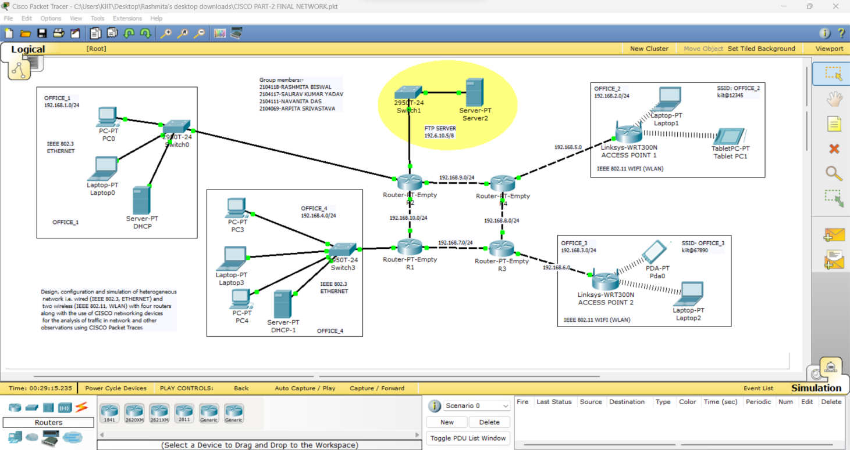

***Software used:***



**CISCO Packet Tracer**

***Network Specifications :***

* ***Heterogeneous Network (Table. 1)***

|  |  |  |  |
| --- | --- | --- | --- |
| **Name** | **Network Address** | **IP Configurations** | **Gateway** |
| OFFICE_1 | 192.168.1.0/24 | 192.168.1.2/24 -  192.168.1.254/24 | **192.168.1.1/24** |
| OFFICE_2 | 192.168.2.0/24 | 192.168.2.2/24 -  192.168.2.254/24 | **192.168.2.1/24** |
| FTP SERVER | 192.6.10.0/8 | 192.6.10.2/8 -  255.255.255.254/8 | **192.6.10.1/8** |
| OFFICE_3 | 192.168.3.0/24 | 192.168.3.2/24 - 192.168.3.254/24 | **192.168.3.1/24** |
| OFFICE_4 | 192.168.4.0/24 | 192.168.4.2 - 192.168.4.254/24 | **192.168.4.1/24** |

* IP Configuration: **Dynamic Host Configuration Protocol (DHCP)**

**Note:** All are Class-C Networks default subnet mask: **255.255.255.0**

* ***FTP SERVER (Network Address : 192.6.10.0/8 )***

**Class-C Networks default subnet mask: 255.255.255.0**

* ***Cable Specifications***
  + Connections > Copper Straight -Through

(Between PC/Laptop/Server to Switch and Switch to Routers)

* + Connections > Copper Cross – Over

(Between same device like Switch to Switch and Routers to Routers)

* ***Switch Specifications***
  + Type: CISCO 2950T-24 (Switch for Wired LAN)
  + IEEE 802.3 Fast Ethernet (FE-Copper)
  + Standard: 100-Base_TX
* ***Wireless Access Points / Routers***
  + - Type: Linksys-WRT300N
    - IEEE 802.11 standard - ISM Band 2.4 GHz
    - Authentication: WPA2-PSK
    - Encryption: AES
    - SSID: OFFICE_2 and OFFICE_3 for respective office location
    - Pass Phrase: kiit@12345 for OFFICE_2 and kiit@67890 for OFFICE_3
    - LAN: IP Configuration: DHCP as per ***Table.1***
* ***Router Specifications***
  + Type: Generic (Router-PT-Empty)
  + Add Hardware interfaces: Fast Ethernet 100 Mbps
  + Network Interface Card (NIC) – Network Adaptor : IEEE 802.3 Fast Ethernet (FE-Copper)
  + Standard: 100-Base_TX
  + 4 NICs for Router 2 (R2)
  + 3 NICs for Router 1 (R1), Router 3 (R3) and Router4 (R4)
  + Routing Protocol: Routing Information Protocol v.1 (RIP v1)

**Intermediate Network Specifications :**

|  |  |  |
| --- | --- | --- |
| **Between Routers** | **Network Address** | **IP Address of Gateways** |
| AP (OFFICE_2) – R4 | 192.168.5.0/24 | 192.168.5.1 & 192.168.5.2 |
| AP (OFFICE_3) – R3 | 192.168.6.0/24 | 192.168.6.1 & 192.168.6.2 |
| R1-R2 | 192.168.10.0/24 | 192.168.10.1 & 192.168.10.2 |
| R1-R3 | 192.168.7.0/24 | 192.168.7.1 & 192.168.7.2 |
| R2-R4 | 192.168.9.0/24 | 192.168.9.1 & 192.168.9.2 |
| R3-R4 | 192.168.8.0/24 | 192.168.8.1 & 192.168.8.2 |

**NB: AP Access Point (Linksys-WRT300N)**

**PC/ Laptop/ Server Specifications :**

* + End Devices > Generic PC/laptop/Server

**Procedure:**

As per the Network scenario diagram given above, the required networking devices like Wireless Access Points, Routers, Switches, PCs, Laptops, Wireless Tablets and Smart devices (PDA) were placed. The required cable connections were made. All devices were configured as per the specifications given above. Some of the device configuration methods (Screenshots) are given below:

***Basic Configuration***

# *Wireless Access Point Configuration (Linksys-WRT300N) Config > Wireless*

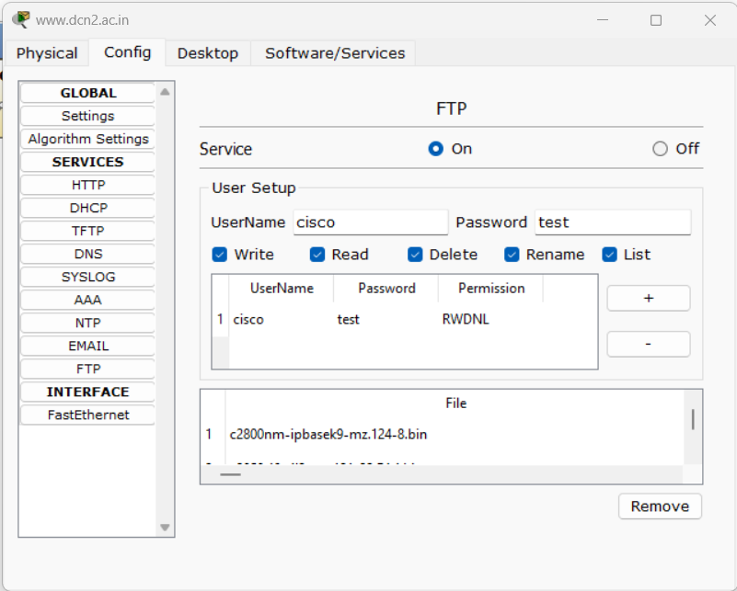***Config > FTP SERVER***

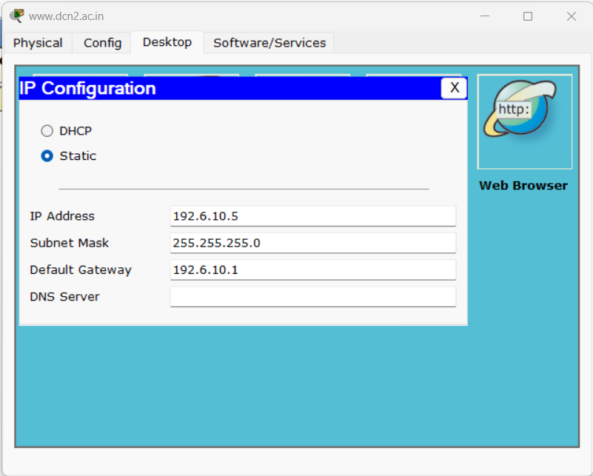

***GUI (LAN→ DHCP Configuration)***

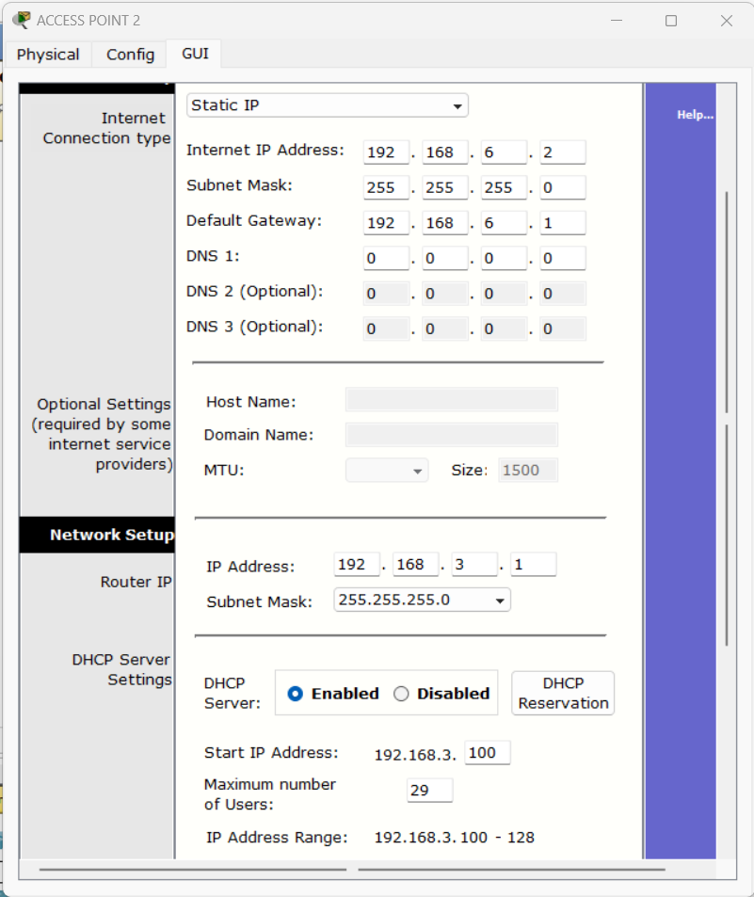

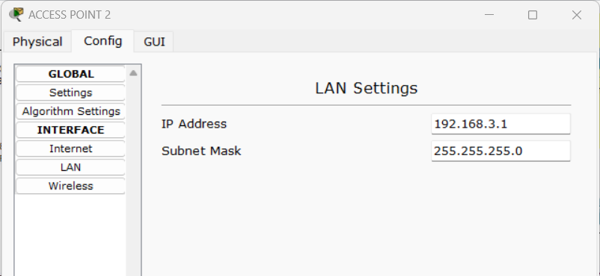***Then, Save Settings.***

1. ***Laptop***

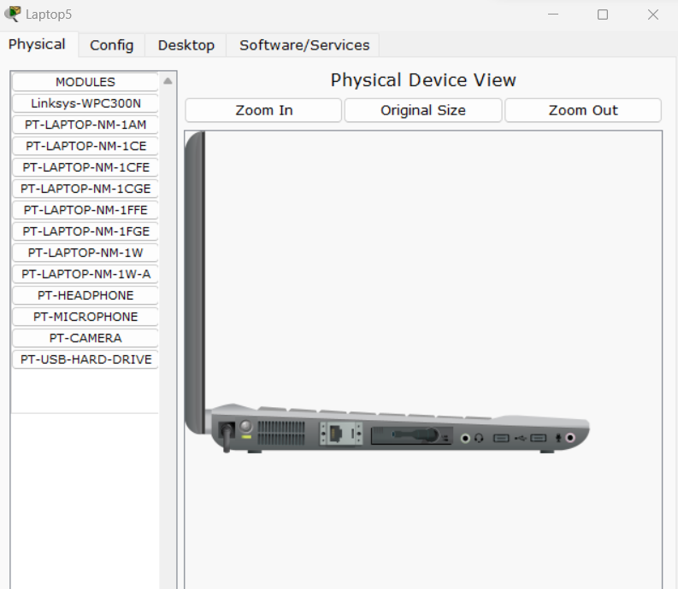

***“Linksys-WPC300N” module is inserted into laptop and then it is switched on.***

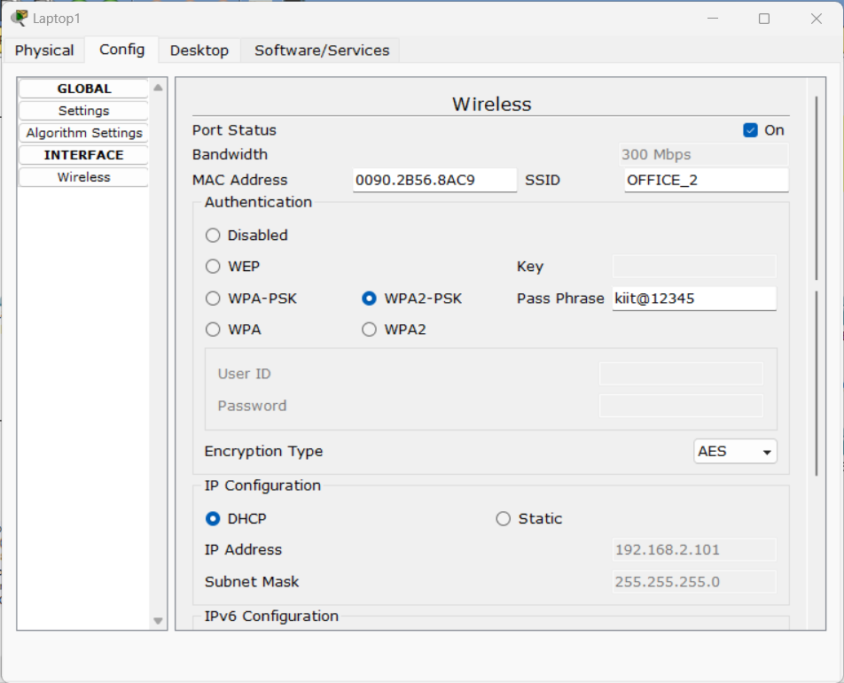

***Config > laptop***

1. ***Wireless Tablet/ Smart device (PDA)***

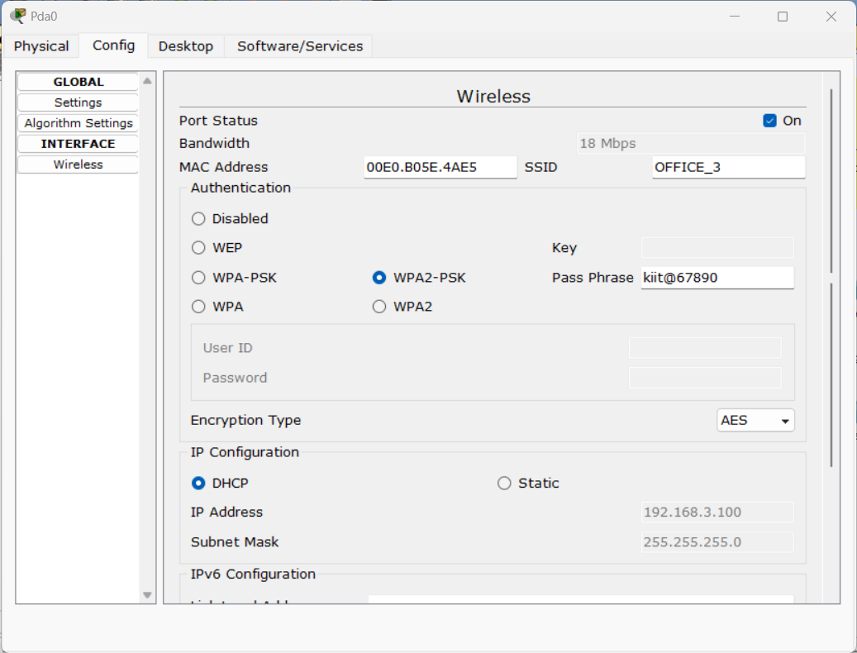

1. ***Other wired end devices***

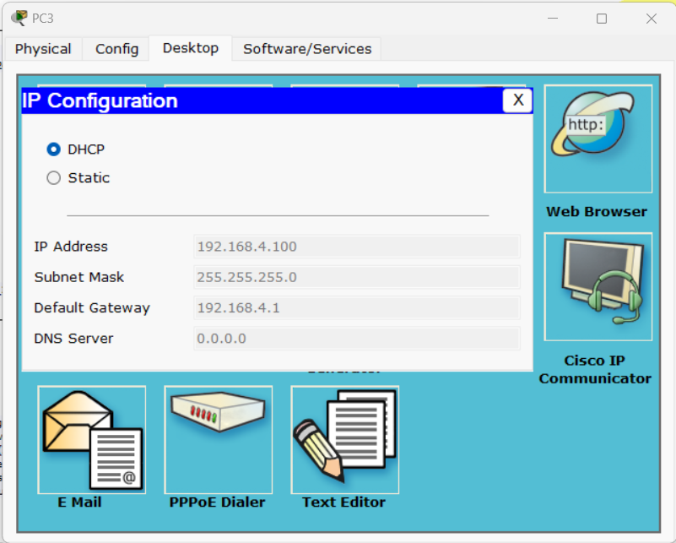

***All PC connected to wired Ethernet Network must be configured as***

***Desktop > IP Configuration > DHCP.***

1. ***DHCP Server***

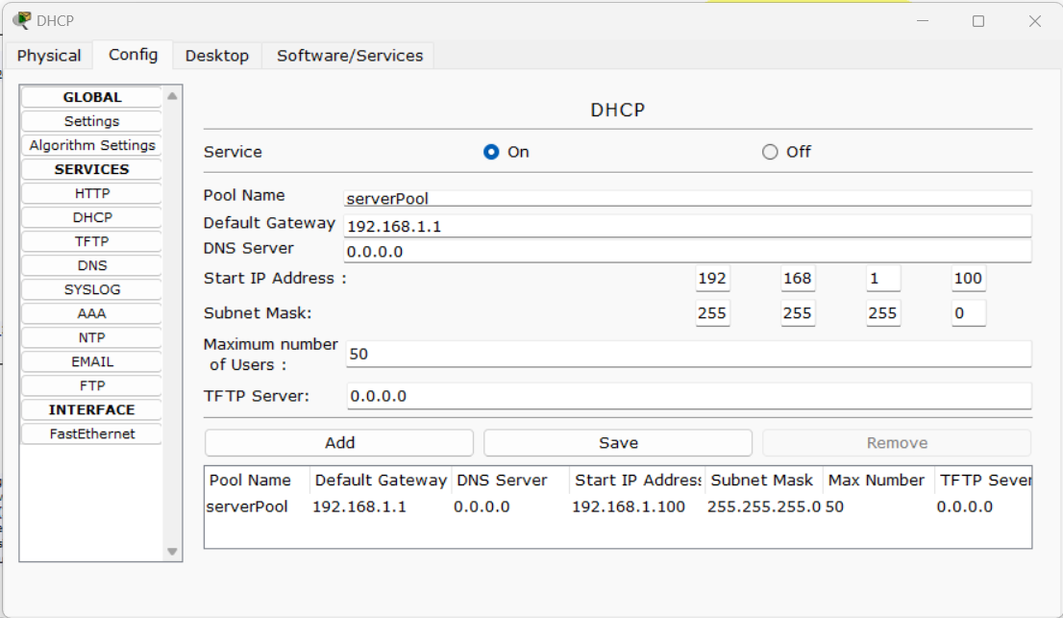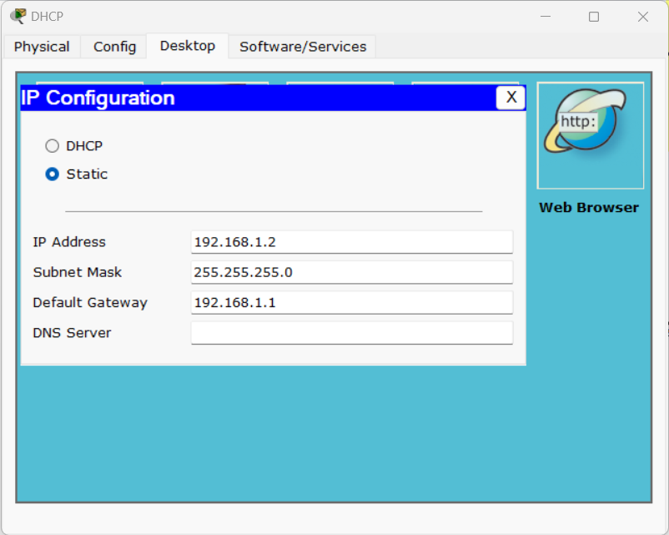

***6.Router***

* Place ***Generic Routers*** from the **Router Menu** from the **Lower left corner of the window**.
* **Double-Click** on **Router** to open **Menu**. In **PHYSICAL TAB**.Add a extra **PT-ROUTER NM-1CFE interface**by dragging and dropping at the back panel of the Router.
* Similar to placement of Router, place **CISCO Catalyst 2950T-24 Switches** and End devices like PC and Server as required.
* Connect **Copper Straight Cable** between **PC-SWITCH, SWITCH-ROUTER**.
* Connect Copper Cross Cable between **ROUTER-ROUTER** and **SWITCH-SWICTH** interfaces. Give the suitable IP Address in Router interface by refer by double clicking on **ROUTER > COFIG > Select the suitable interface> Give the IP Address** in the Space given.

***The above mentioned steps are shown in the figures below:***

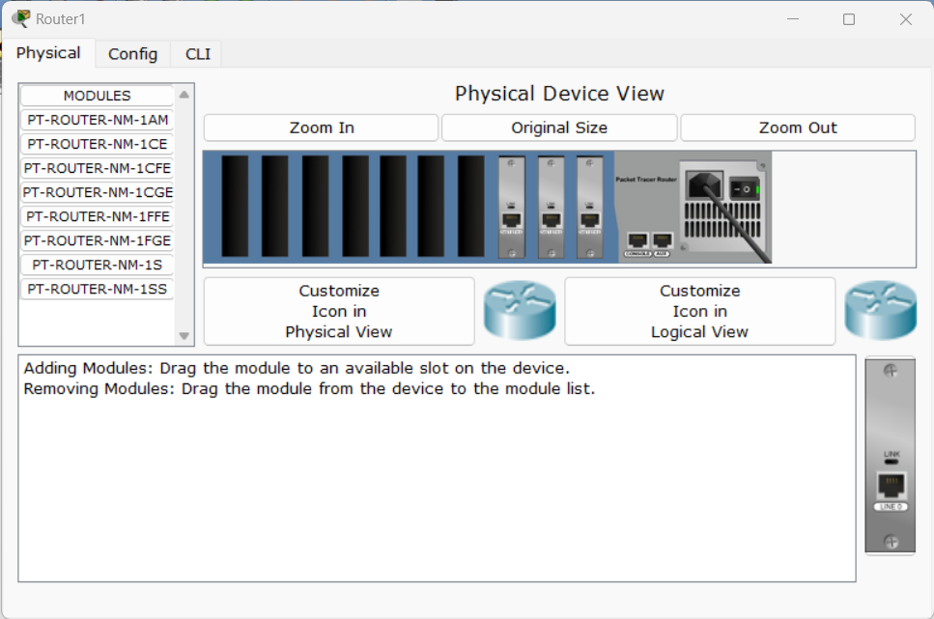

**R1**

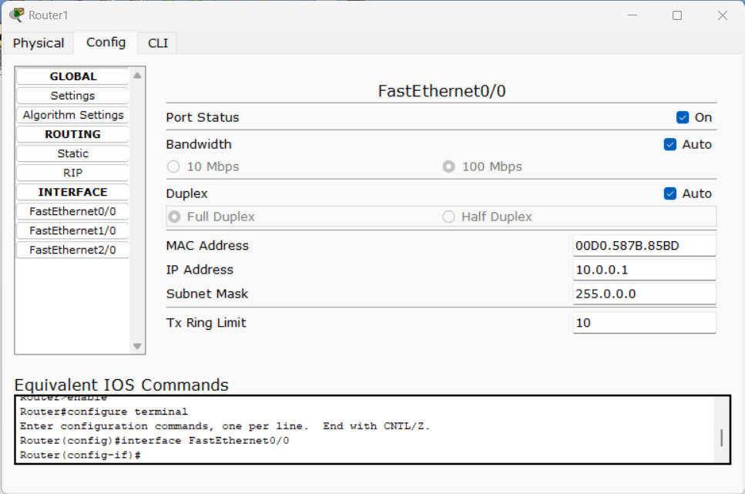

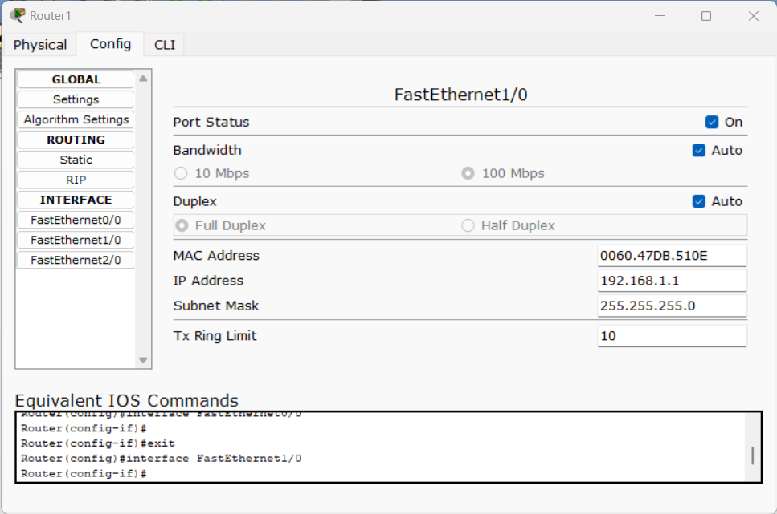

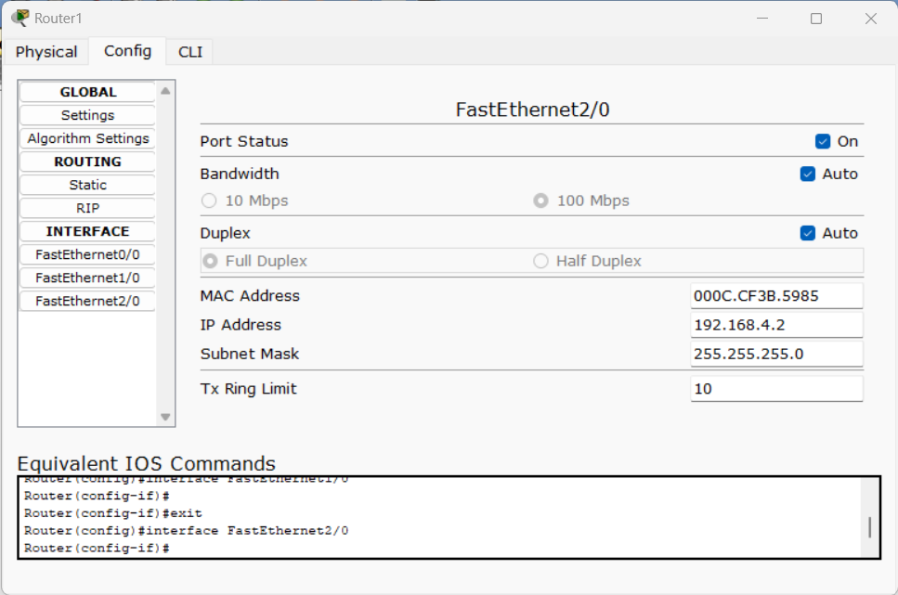

**---------------------------------------------------------------------------**

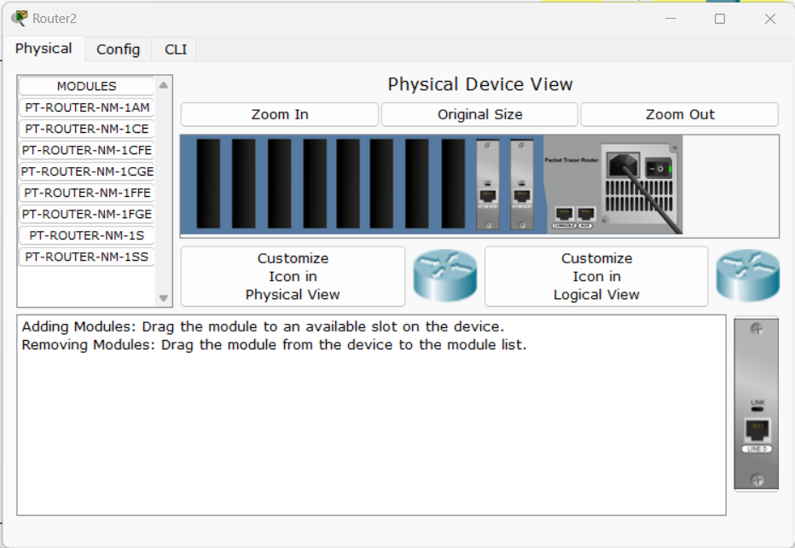

**R2**

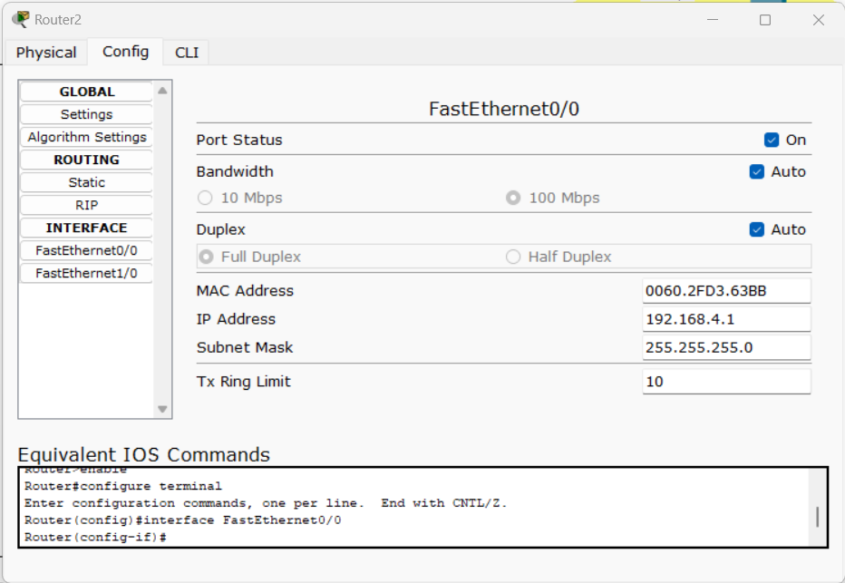

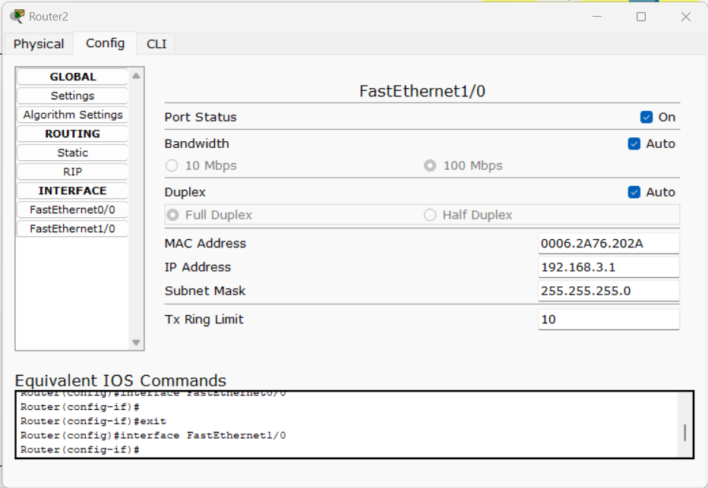

1. 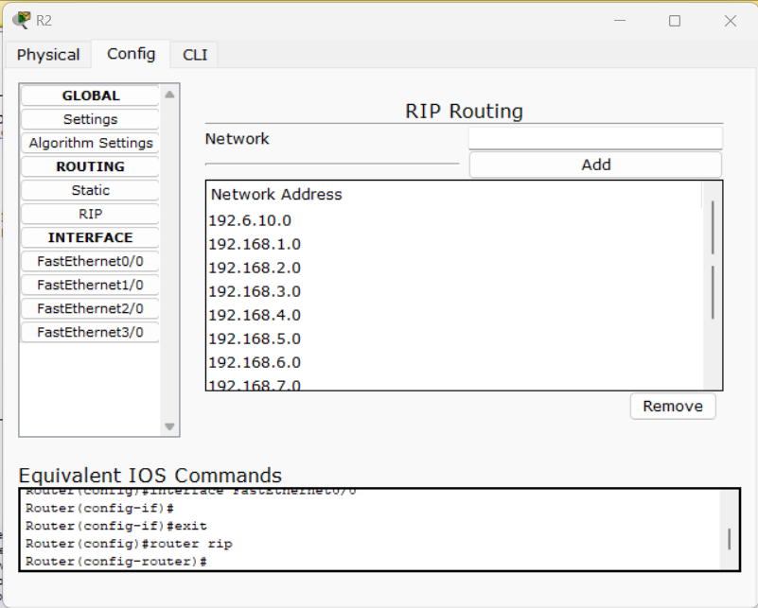***Routing Protocol: RIPv1***

**Observations:**

***After designing and configuring the complete network, followings can verified and observered:***

* ***FTP application server configuration. (put and get)***

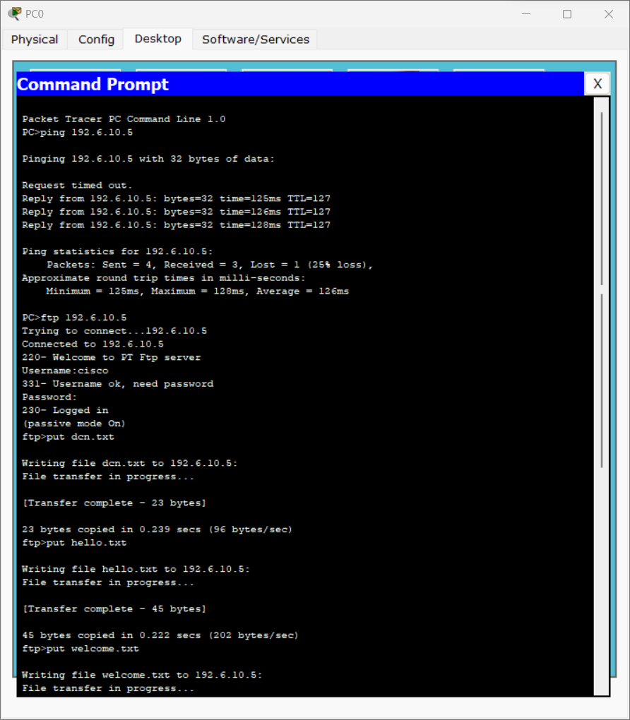

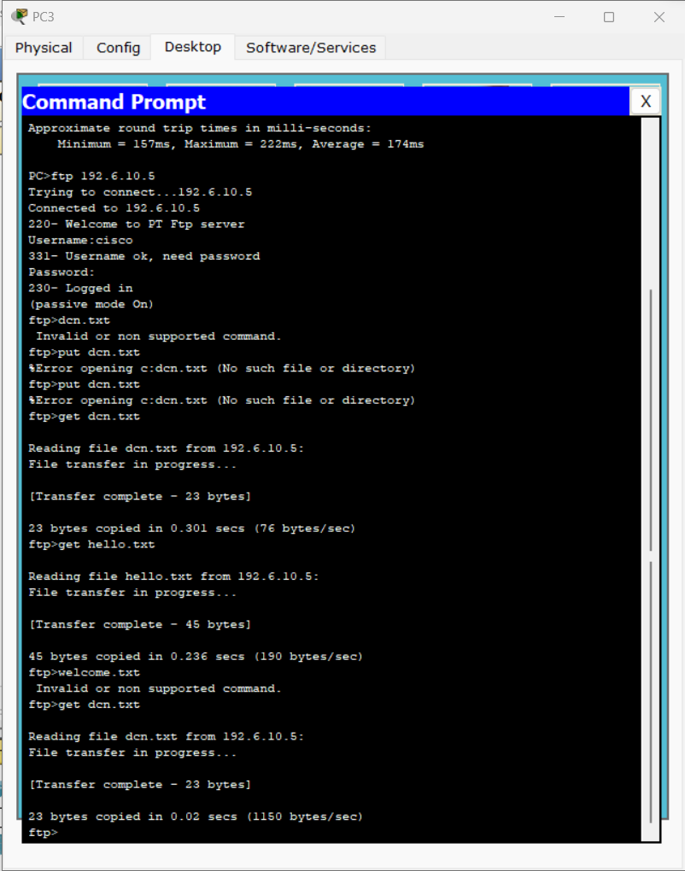

* ***DHCP messages for automatic assignment of IP Configuration.***

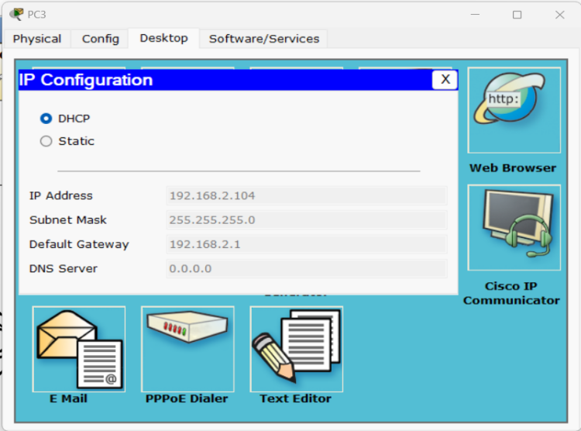

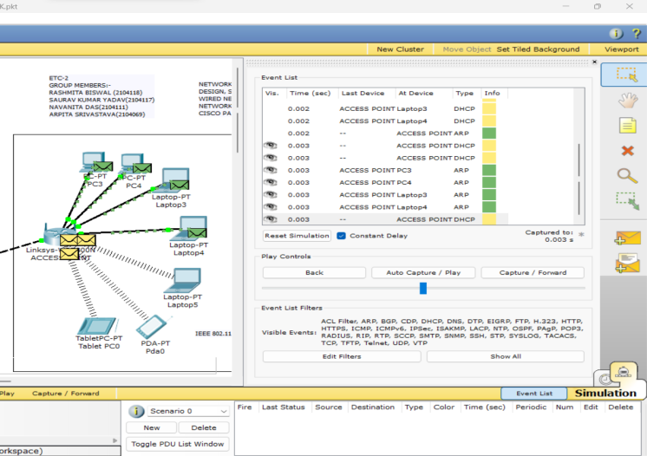

* ***PING Command***

***PC > Desktop > Command Prompt:***

***Ping 192.168.2.101***

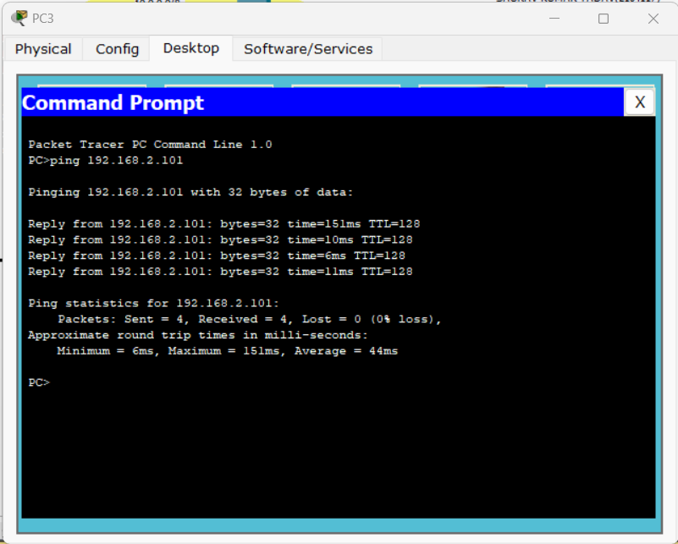

* ***HTTP over TCP Traffic in the Network in Simulation mode***

***PC > Desktop > Web Browser :***

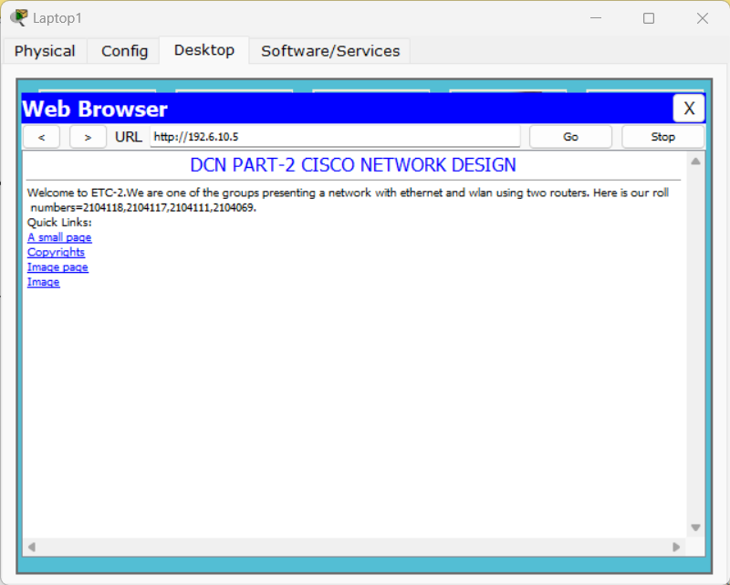

* ***Packet transfer***

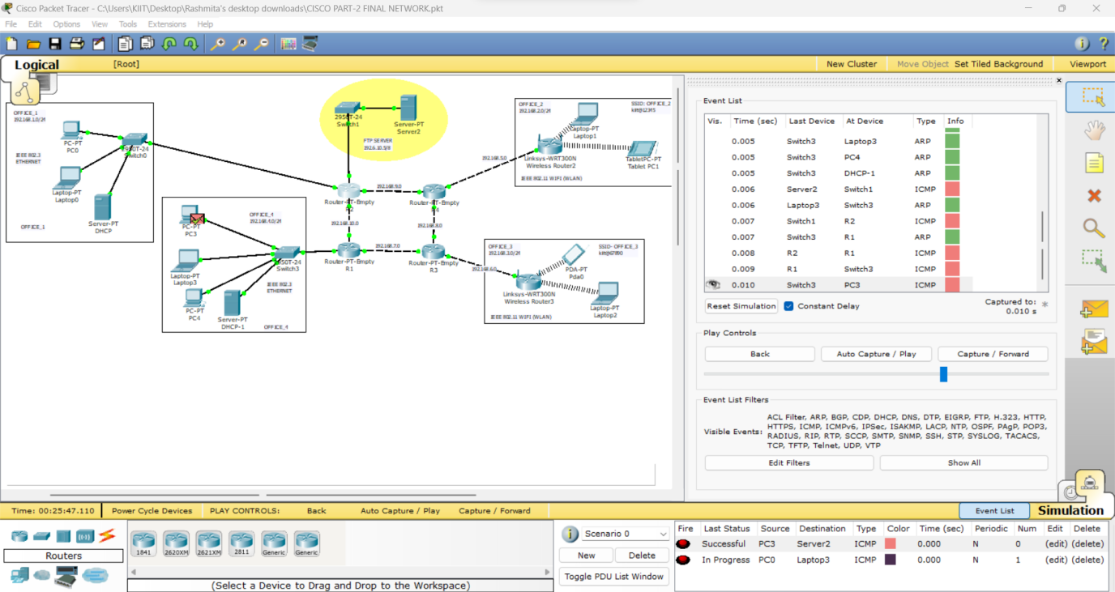

* ***Complex PDU***

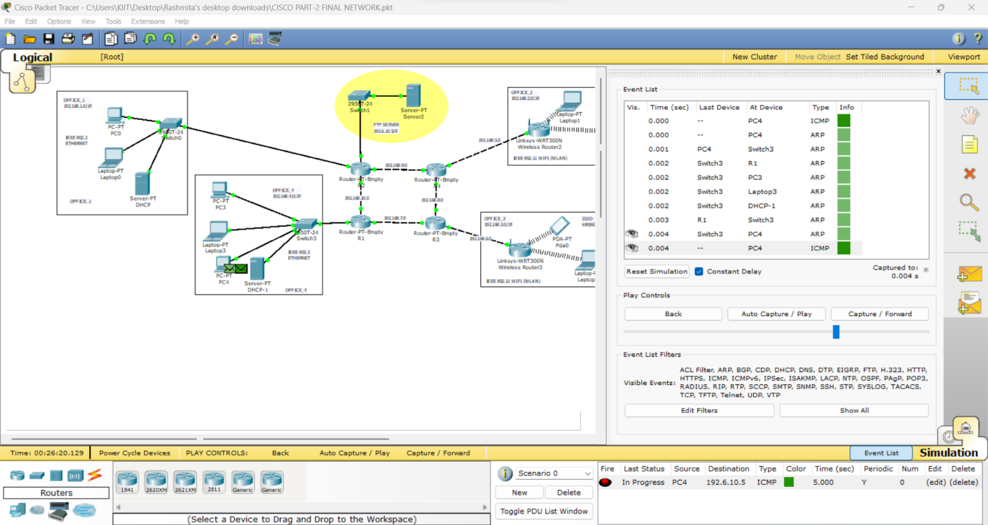

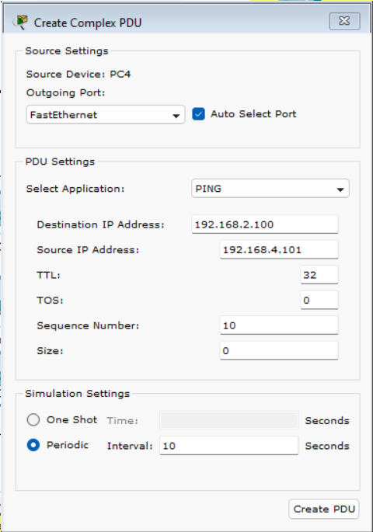

**\*\*\* END OF REPORT \*\*\***